連線H204 Linux PC cluster主機使用範例
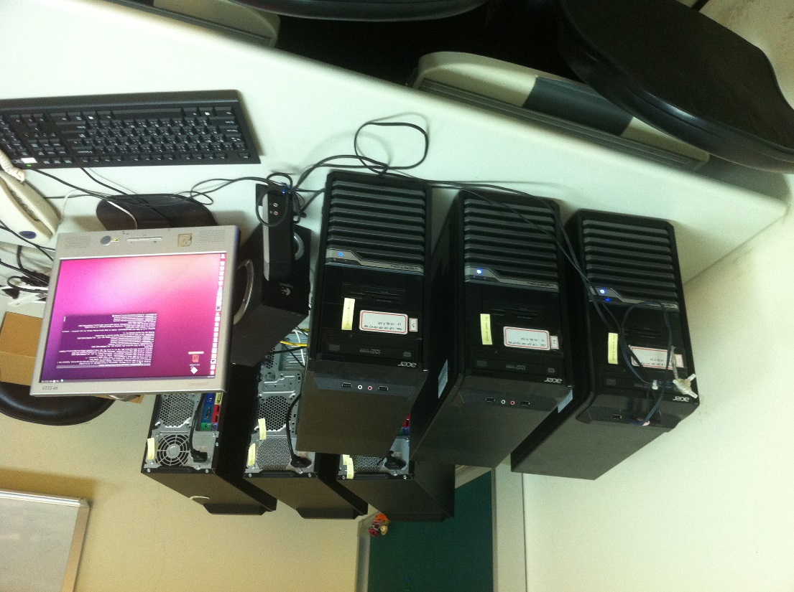
電腦規格
CPU：8核心 3.40GHz *8
RAM：32 GB
HD ：2 TB
OS ：ubuntu 14.04 64bit
Hadoop Cluster
Hadoop 2.4.0 Version
6 nodes hadoop cluster
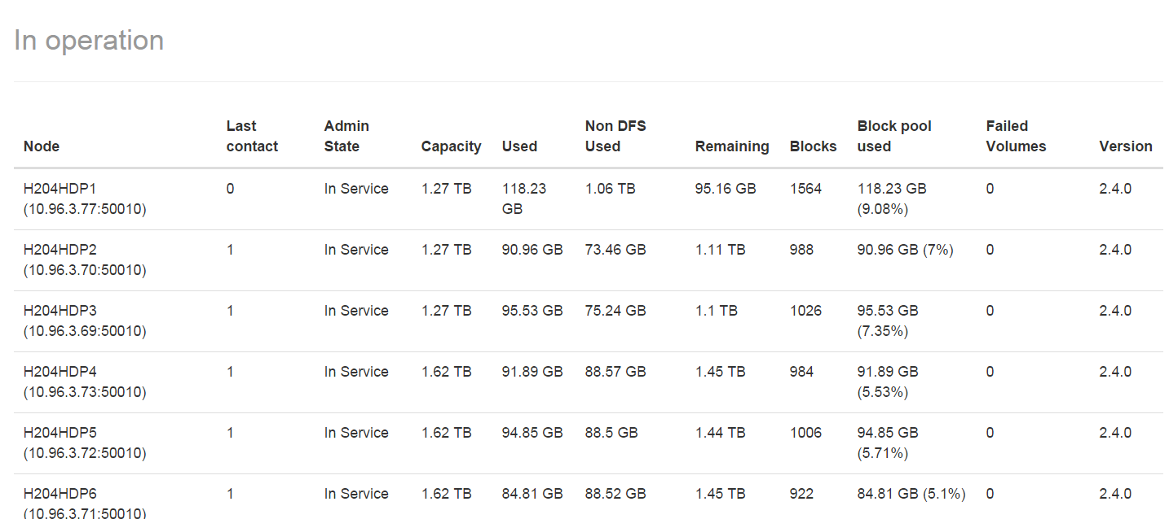
- putty
輸入IP : 10.96.3.77

ListofHadoopUsers 帳密
(課堂確定)
輸入帳密後，「顯示userXXX@H204HDP1:~$ 」，表是連線成功。
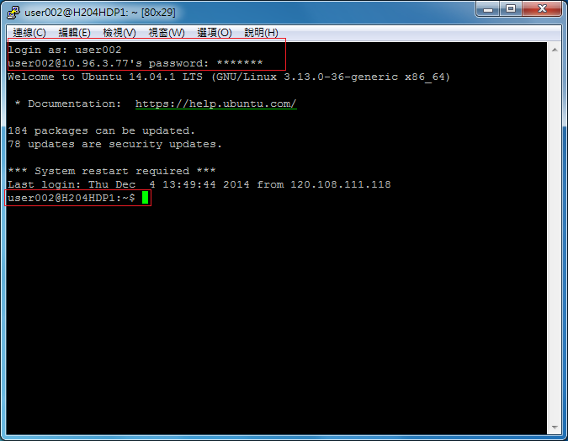
- FTP （程式+資料）
使用FileZilla FTP軟體，連線至Hadoop。
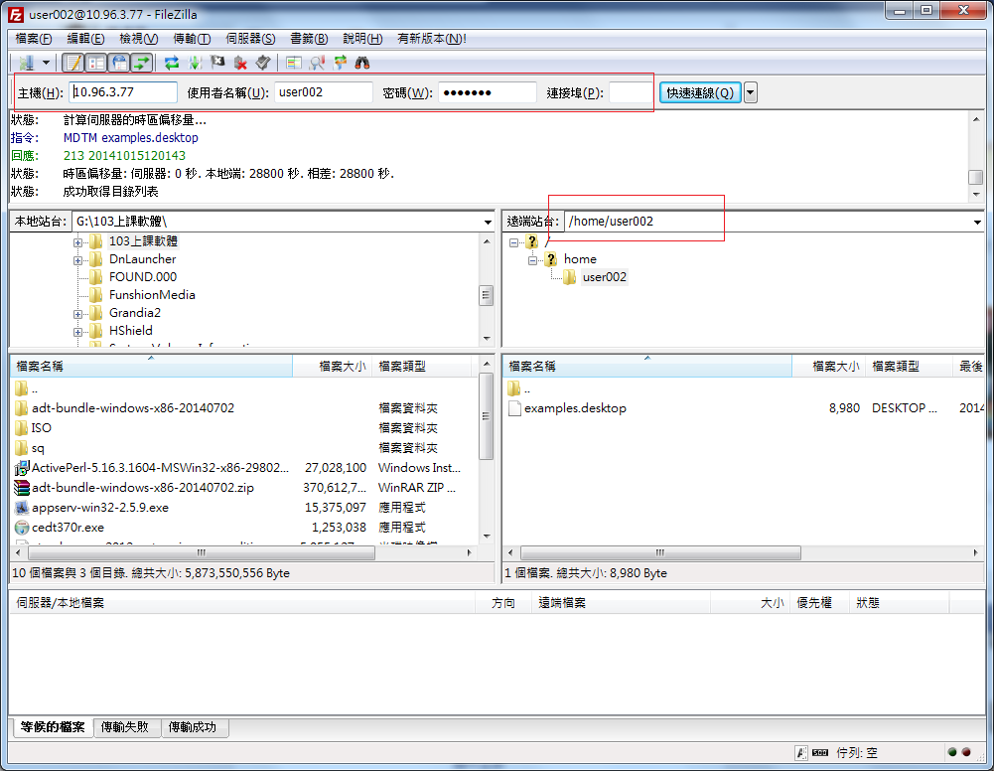
上傳檔案至hadoop
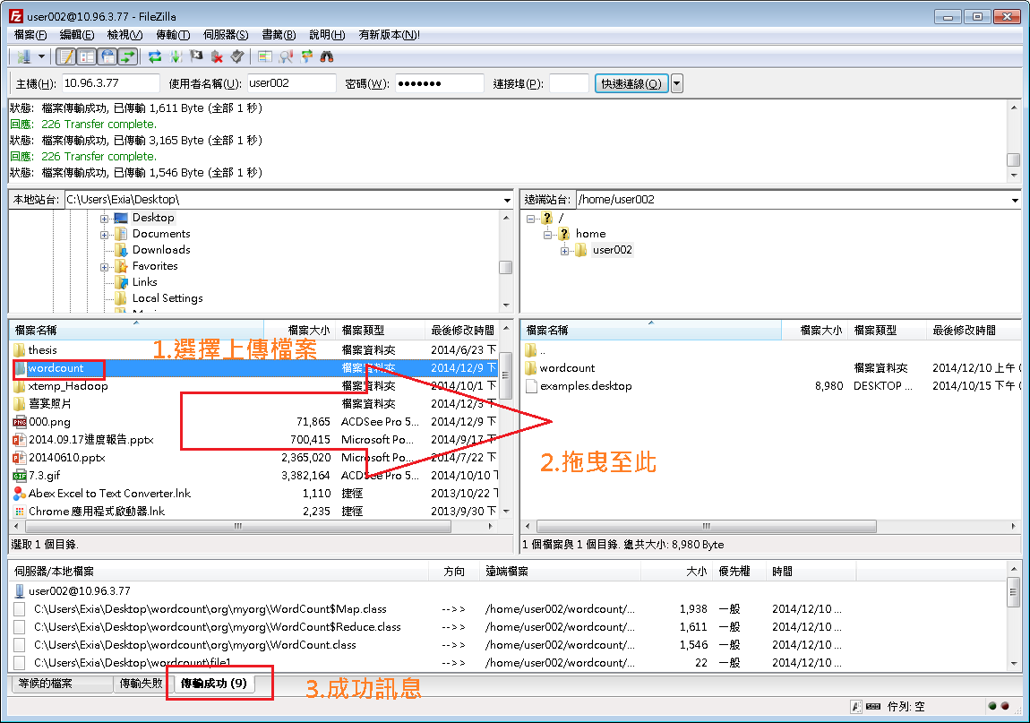
- Wordcount Map Reduce Example
http://hadoop.apache.org/docs/current/hadoop-mapreduce-client/hadoop-mapreduce-client-core/MapReduceTutorial.html
首先到這網站下載wordcount Source Code
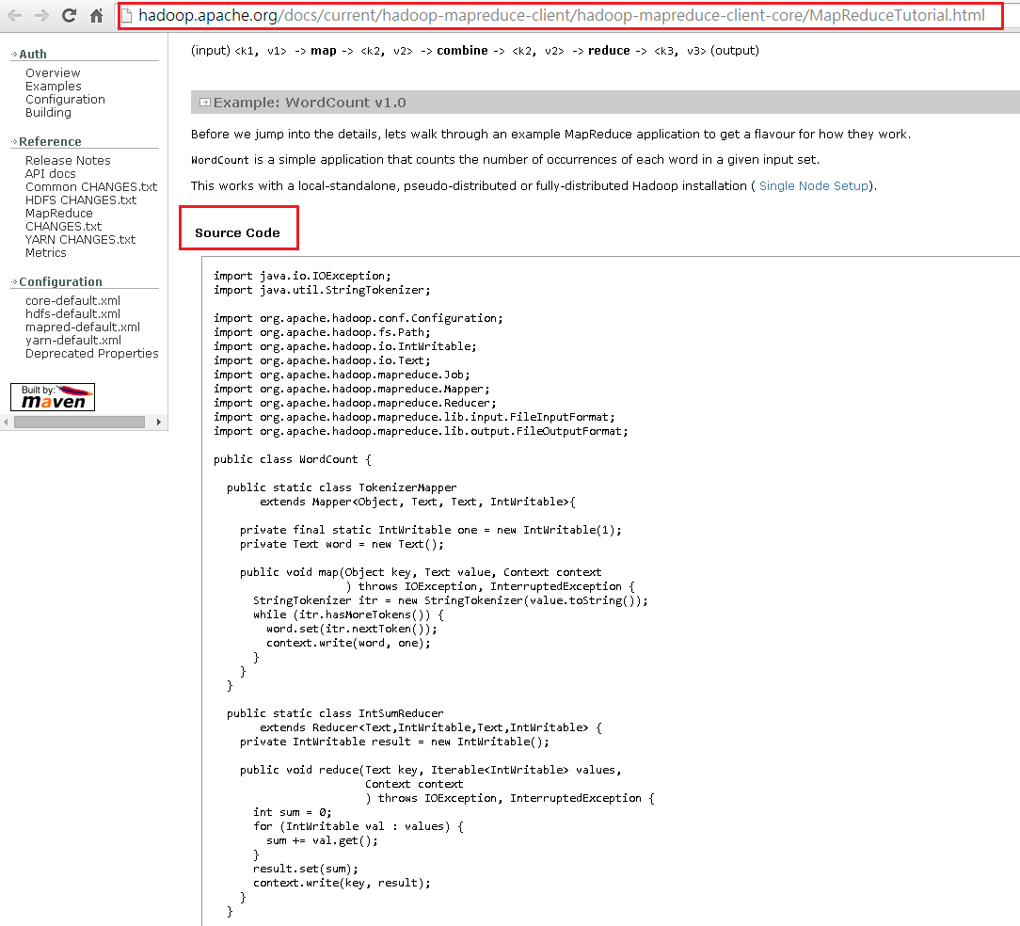
複製程式碼至記事本，另存新檔：WordCount.java
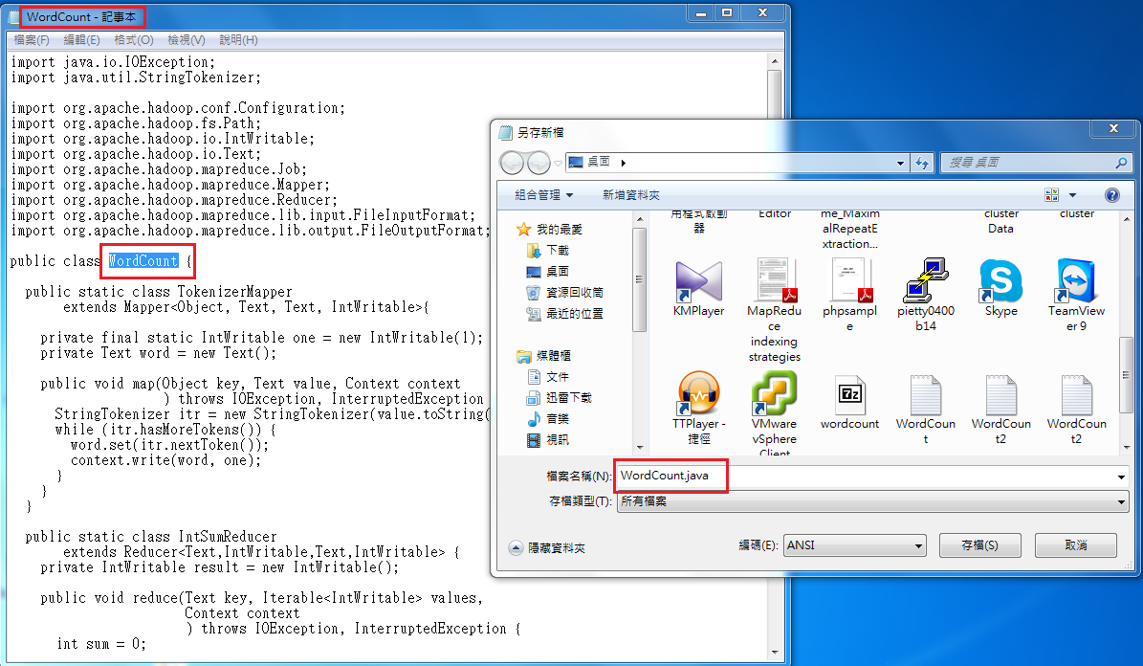
把WordCount.java檔上傳至hadoop
請在路徑: /home/user002/ 底下新增一個資料夾: wordcount
Wordcount資料夾裡要有三個檔案、一個資料夾
wordcount_classes (資料夾)
WordCount.java (程式碼)
File1.text (input)
File2.text (input)
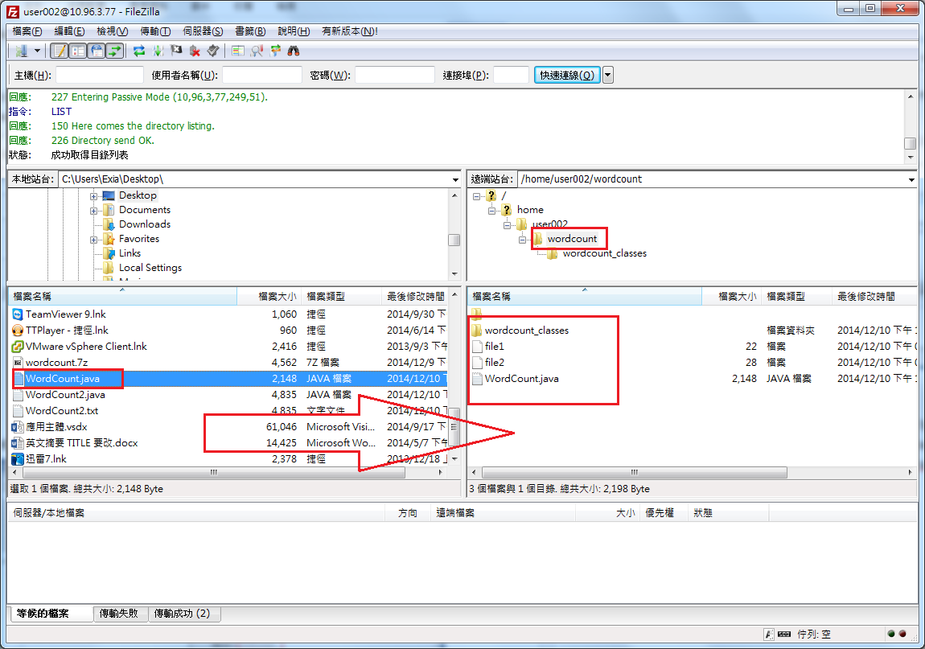
File1.txt input檔:內容(wordcount 要查詢的內容)
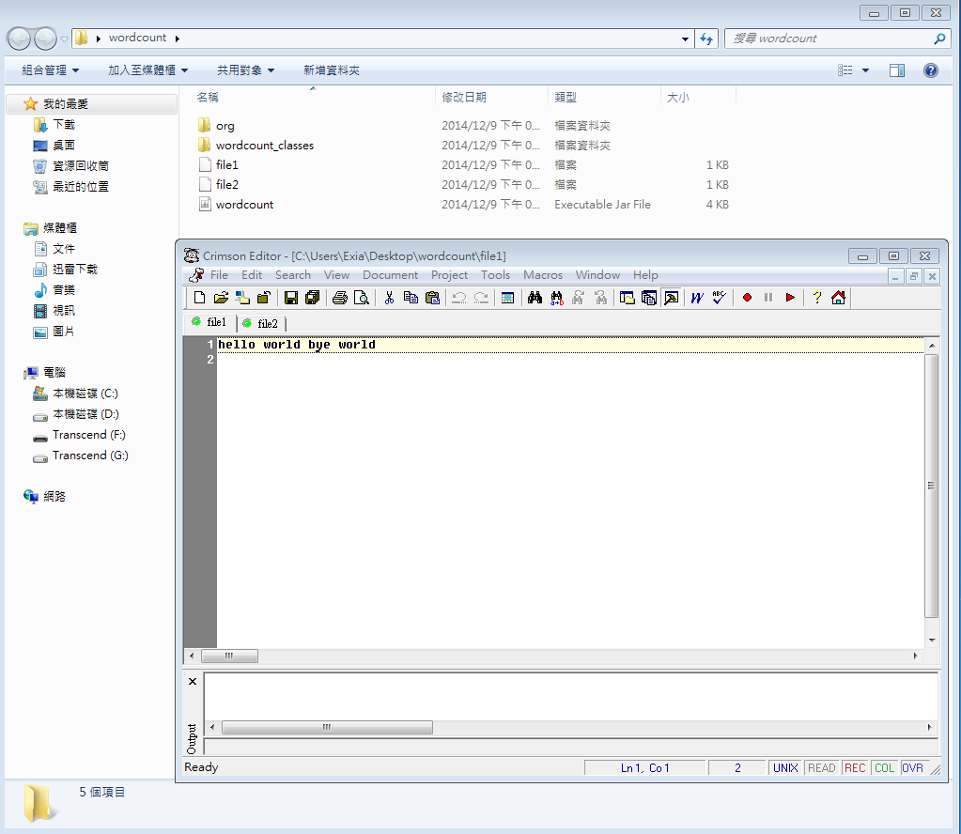
- Compile Code
javac -classpath /usr/local/hadoop/share/hadoop/common/hadoop-common-2.4.0.jar:/usr/local/hadoop/share/hadoop/mapreduce/hadoop-mapreduce-client-core-2.4.0.jar -d wordcount_classes WordCount.java
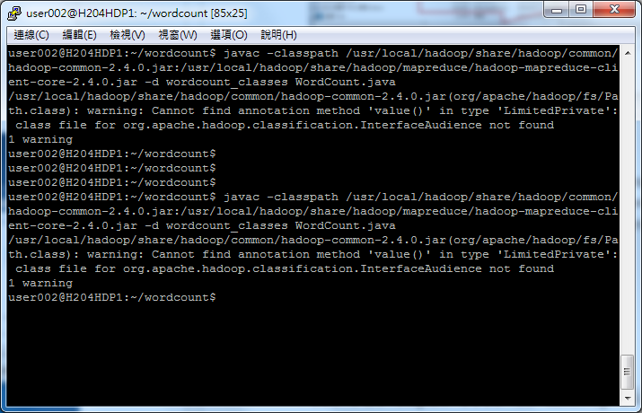
- Make Jar File
cd wordcount_classes/
jar cvf wordcount.jar *.class
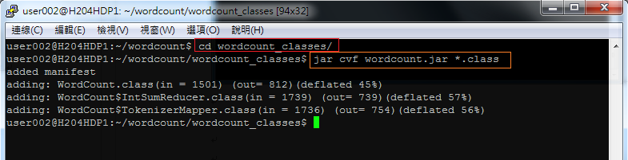
- Put input file to Hadoop File System
從local端傳送檔案至HDFS (Hadoop File System)
hadoop fs -ls / (查詢HDFS上的使用者)
hadoop fs -mkdir /userXXX (在HDFS上新增userXXX資料夾)
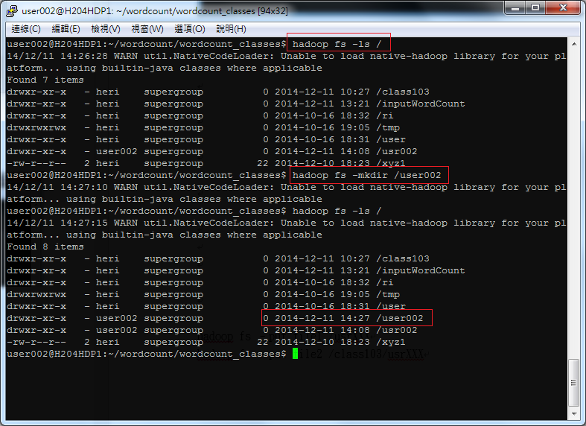

hadoop fs -put file1 /userXXX (把file1檔上傳至userXXX資料夾裡)
hadoop fs -put file2 /userXXX (把file2檔上傳至userXXX資料夾裡)
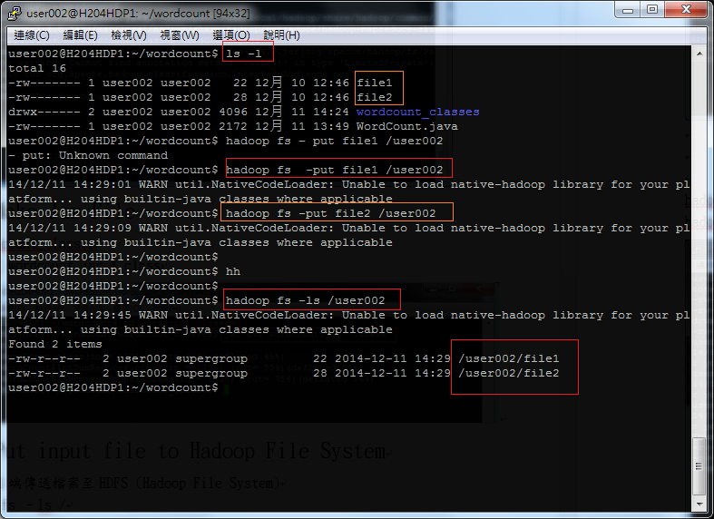
- Running WordCount
hadoop jar wordcount.jar WordCount /userXXX /userxxx/output
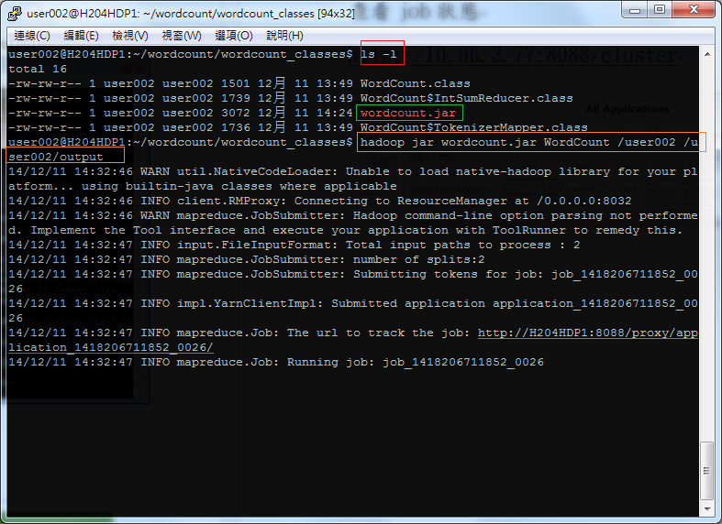

查看結果
Hadoop fs -cat /user002/output/part-r-00000 (output檔目的地)
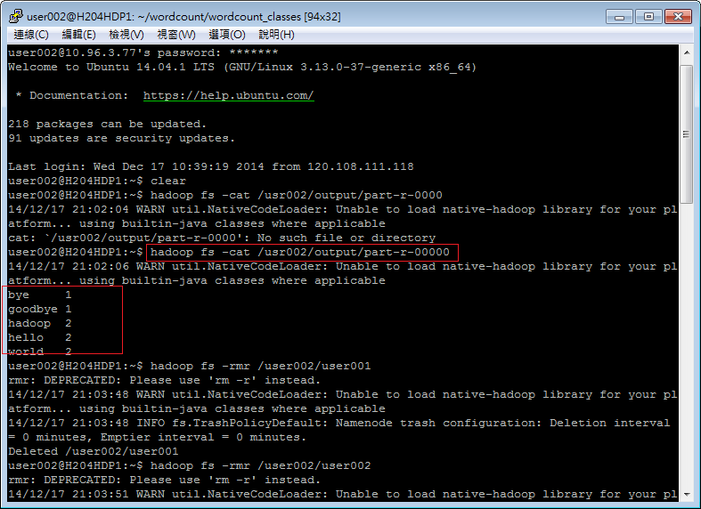
可查看hadoop 狀態
http://10.96.3.77:50070/
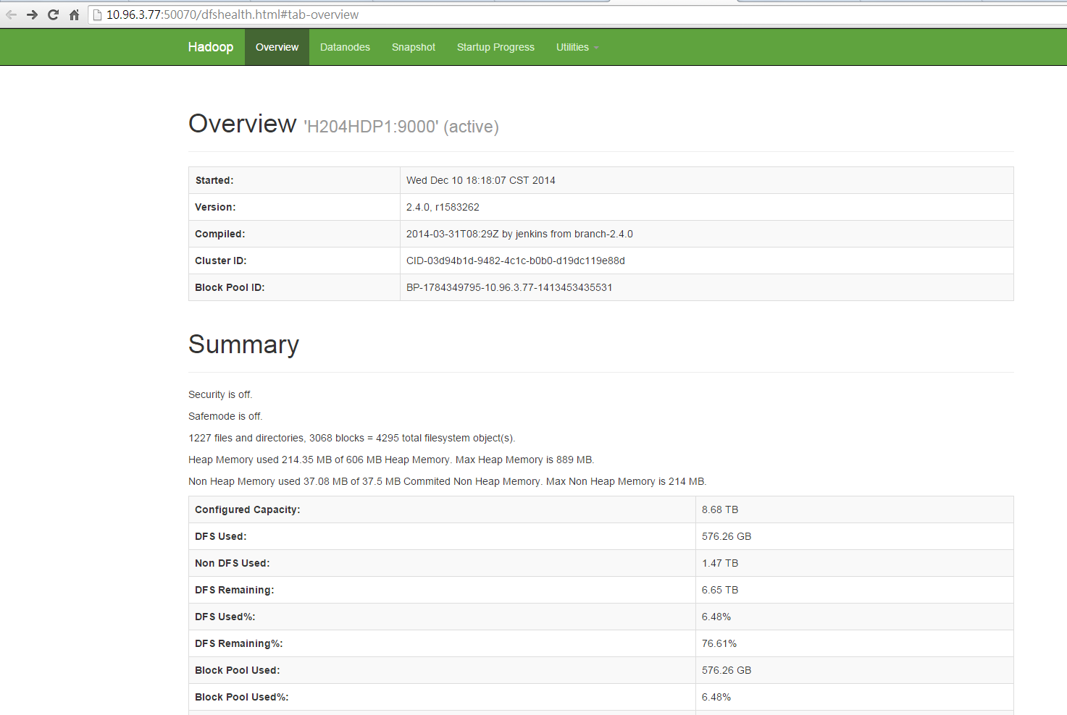
點選Browse the file system查看HDFS上的檔案
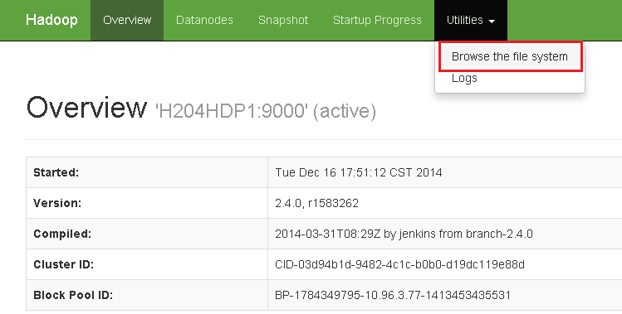
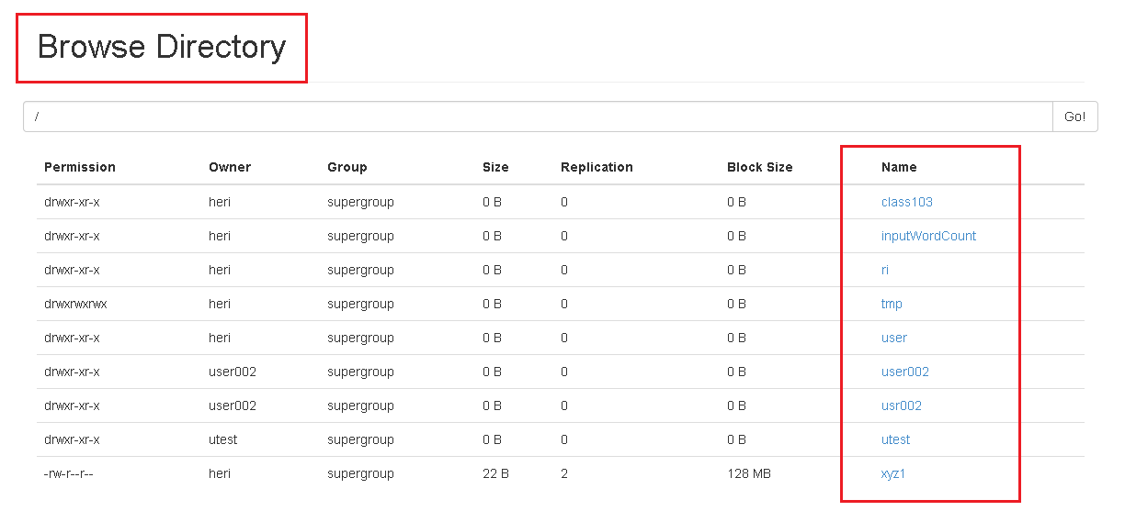
查看job狀態
http://10.96.3.77:8088/cluster
